UNIT 2 BIOSAFETY GUIDELINES
Genetically Modified (GM) Crops
Recombinant DNA technology can be used for insertion of genes in plants not only from related plant species but also from unrelated species such as microorganisms. The process of creation of transgenic plants is for more precise and selective than traditional breeding. Application of recombinant Technology is primarily for the production of transgenic plants with higher yield and nutritional content, increased resistance to stress and pests. Several commercially important transgenic crops such as maize, soyabean, tomato, cotton, potato, mustard, rice etc. have been genetically modified and reported.
Modern molecular biology tools are increasingly being used to produce GMOs with novel traits using genetic engineering, genetic modification or recombinant DNA technology. These involve isolation of nucleic acid molecules from one organism and their introduction into another organism altering the genetic make-up of the recipient permanently and allowing them to be inherited by offspring.
The genetically engineered traits include insect pests resistance, herbicide tolerance and virus resistance.
Insect resistance:
Biotechnology has opened up new avenues for natural protection for plants by providing new biopesticides, such as microorganisms, that are toxic to targeted crop pests but do not harm humans, animals, fish, birds or beneficial insects.
Disease resistance:
Plants are susceptible to viral, bacterial and fungal diseases. Much progress has been made in evolving transgenic plants resistant to viruses. For example, expression of a gene that encodes the coat protein of tobacco mosaic virus (TMV) in transgenic tobacco plants has been shown to cause the plants to resist TMV infection. A number of other viral resistant plants species have been developed including squash and potatoes.
Produce quality improvement:
One of the most successful research efforts to change the characteristics of a plant produce was carried out with tomatoes. Tomatoes need to be picked while still green so that they are firm enough to withstand mechanical handling and transport. Unfortunately, they do not develop the same flavor and texture of vine- ripened tomatoes.
Risk to Human Health:

Risks of GMOs to human health are related mainly to toxicity, allergenicity and antibiotic resistance of the new organisms/products. The risk of toxicity may be directly related to the nature of the product whose synthesis is controlled by the transgene or the changes in the metabolism and the composition of the organisms resulting from gene transfer. Every GMO needs to be carefully evaluated for toxicity to human and animals. Most of such toxicity risks can be assessed using scientific methods both qualitively and quantitatively.

1. Allergenicity
GM crops allergen reaction is rising up as an issue from time to time. Food allergens are caused by specific proteins found naturally in products such as, milk, eggs, wheat, fish, tree nuts, peanuts, soybeans and shellfish etc. might cause up to 90% food related allergens. The fear is either the protein from one of these food types were incorporated in to a food were it is not normally found or a gene from unrelated species incorporated in to crops this may produce protein that lead to allergens. WHO concludes, GM foods have the potential to cause allergen reaction but this risk is comparable to the risks associated with traditional grown foods. The proteins produced by any newly introduced genes have the potential to cause allergies. When introducing a gene in to an organism the level of allergens in the modified organism may be increased above the natural range in the convectional food or new allergen may be introduced. Since the primary product of gene expression is protein, and most of food allergens are proteins, there exists a possibility that any novel protein introduced in to a plant might be an allergen. For example a proposal to incorporate a gene from Brazil nut to soybean was abandoned because of the fear of causing unexpected allergic reaction. Bean crop that were genetically modified to increase the level of cysteine and methionine content were discarded after the discovery that the expressed protein of the transgene were highly allergenic. Testing of GM foods may be required to avoid the harm of consumers with food allergens.
2. Toxicity
Toxicity results from the change in the metabolism and the composition of the organism. A research article examined the effect of GM potato on the digestive track on rats were published in lancet. More over the gene introduced in to potatoes was snowdrop flavor lectin, a substance to known to be toxic to mammals. Toxic substances are found in foods naturally but these compounds usually occur at levels of not harmful to humans when foods are consumed or processed appropriately. Concerns are raised on the possibility of introducing new toxic substances or increasing the levels those naturally occurring toxins which are harmful to human health with respect to GM foods

Influence of GMOs on Environments:
The gene transferred into an organism or the resultant products can actually remain in environmental leading to environmental problems. The intentional release of GMOs into the environment has led to an increased interest in possible interactions that may occur between other organisms in the environment. Unintended genomic changes can occur as a secondary consequence of genetic modification. Such changes can lead to production of new proteins that may be toxic or allergenic or may disrupt or alter metabolic pathways that play a role in making the GMO successful.

Gene flow:
Accidental cross breeding between GMO plants and traditional varieties through pollen transfer can contaminate the traditional local varieties with GMO genes resulting in the loss of traditional varieties of the farmers.
Resistance / tolerance of target organisms:
The potential benefits of planting insect-resistant transgenic crops include decreased insecticide use and reduced crop damage. However, the innate ability of insect populations to rapidly adapt to environmental pressures poses a serious threat to the long-term efficacy of insect-resistance. Adaptation by insects and other pests to pest protection mechanisms can have environmental and health impacts.
Increased weediness:
Weediness means the tendency of the plant to spread beyond the field where it was first planted. There are apprehensions about GM crops becoming weeds. For example, a salt tolerant GM crop if escapes into marine areas could become a potent weed there.
There is also fear about the development of superweeds i.e. a weed that has acquired the herbicide tolerant gene due to genetic contamination with a herbicide tolerance GMO through in field cross breeding to related species or through horizontal gene transfer.
Disruption of the food web
Another issue is the possibility that the insect-resistant plants might increase the number of minor pests while reducing the major type of pest. The scenario here is that the pest population might shift from those put-off by the engineered plants to other, undaunted species. This shift, in turn, might unleash a pervasive disruption of the entire food chain, with new predators of the new insect species, and so on up to the top of the chain. Or the disruption might work in the other direction, whereby residues of herbicide or insect resistant plants might generate negative effects on organisms (e.g. bacteria, fungi, etc.) found in surrounding soil.
Loss of Biodiversity/reduction of cultivars:
There have been concerns about reduction in the genetic diversity in cropping systems by the development and global spread of improved crop varieties to the green revolution. This genetic erosion has occurred as the farmers have replaced the use of traditional varieties with monocultures. This is expected to further intensify as more and more transgenic crops are introduced which bring in considerable economic benefits to the farmers. The relative rate of susceptibility to any unforeseen infections or destructive situations increases when single varieties are used in cropping system in place of multiple varieties.
Changes in the soil ecology:
Many plants leak chemical compounds into the soil through their roots. There are concerns that transgenic plants may leak different compounds than conventional plants, as and unintended sequence of their changed DNA. Speculations are that this may change the ecology of the soil in terms of functional composition and biodiversity. The interaction between plants and solid microorganisms is very complex, with the microorganisms living around plant roots also secreting chemical compounds into the soil.
The first and as yet the only GM crop approved for cultivation in India is the “Bt-cotton” which confer resistance to boll worm which is a menace in cotton crop. The transgenic crop acerage in India is currently around 1.2 million hectares. The acreage is likely to increase sharply in forthcoming years because of its high yielding nature with boll worm resistance. The transgenic cotton crop is gaining momentum in India. The other transgenic crops such as Pigeon pea, Brinjal, Potato, Tomato, Bhendi, Mustard, Cabbage, Rice are under experimental and evaluation stage.
Risks associated with use of bacterial resistance genes in the generation of GM plants

The risks of using bacterial AR genes in the construction of GM plants, where they are introduced into a commercial cultivar, can be defined as direct or indirect. Direct risks are those concerning plant tissue that becomes toxic to anyone/anything consuming it (cf. the native crop that is non-toxic). Indirect risks are those pertaining to adverse effects on human health, other than toxicity, such as damage to the quality of life or to the environment, that arise from GM crop cultivation.
Direct risks
These can be evaluated as:
1. Introduction into the plant of a toxic DNA sequence (i.e. the particular section of DNA is toxic to man). This is a strictly hypothetical situation, since it is generally accepted that all DNA sequences behave chemically in the same way, in that there is no history of any piece of DNA being toxic to humans or any other animal and that large quantities of DNA are eaten by everyone on the planet on a daily basis as an integral component of food without harm;
2. Production of toxicity as a consequence of expression of the bacterial genes (i.e. production of toxic RNA or toxic proteins from the bacterial DNA sequence);
3. Production of a toxic compound arising from the activity of the product of the bacterial gene in the plant.
Indirect risks
These include:
1. Spread of resistance genes from GM crops to other plants;
2. Increased opportunities for AR genes to spread among human/ animal bacterial pathogens (actual or potential).

Risk Assessment and Management:

Risk assessment refers to the possibility of quantitatively measuring the impact or loss caused by a particular phenomenon. Risk assessment is a process that includes three steps: risk identification, analysis, and assessment, and provides a basis for risk management.

Risk identification
Risk identification refers to the process of systematically, comprehensively, and continuously discovering, exemplifying, and describing risk factors using relevant knowledge and methods.
The purpose is to find the main risk factors and the relationship between various risk factors to provide a basis for further research and decision-making. Risk identification is the basis of risk Management

Risk analysis
The purpose of risk analysis is to understand the nature of risk, to provide information support for risk assessment and determination of the most appropriate risk management strategy and method.

Risk assessment
Risk assessment is the process of comparing the results of a risk analysis with a given risk criterion or comparing the results of a personalized risk analysis to determine the severity of the risk and make a decision. Risk assessment evaluates and compares the scientific evidence regarding the risks associated with alternative activities.
Risk management develops strategies to prevent and control risks within acceptable limits and relies on risk assessment. In addition to the scientific assessment, it also takes into consideration various factors such as social values and economics.
Risk communication involves an ongoing dialogue between regulators and the public about risk and options to manage risk so that appropriate decision can be made. Risk assessment should be carried out on case by case basis.

It has been generally accepted that details of risk assessment procedures may vary from case to case but there are few logical steps that need to be followed:
1 Identification of potential adverse effects on human health or environment
2 An estimation of likelihood of these adverse effects
3 An evaluation of identified risks
4 Considerations of appropriate risk management strategies
5 Assessment of overall potential environmental impact and consequences
6 A recommendation as to whether or not the risks are acceptable or manageable.
Contents and methods of risk assessment in biosafety laboratories

Biosafety laboratory risk assessment is a dynamic, systematic work involving pathogenic microbial hazards, laboratory activities, facilities and equipment, personnel, laboratory methods, natural disasters, fire protection, electrical appliances, hazardous chemicals and related gases, etc. Risk analysis methods are commonly divided into qualitative and quantitative analysis, including brainstorming, scenario analysis, pre-hazard analysis, hazard and operability analysis, fault tree analysis, event tree analysis, etc. A comprehensive assessment of risk is usually performed by matrix analysis or risk mapping.

Risk assessment of pathogenic microorganisms
Infectious diseases caused by exposure to pathogenic microorganismsNare a long-standing and certain risk to humans. In the national standard ‘‘General Requirements for Laboratory Biosafety” (GB 19489-2008), the laboratory biohazard assessment is as follows:
‘‘When the laboratory activities involve infectious or potentially infectious biological factors, the assessment of the extent of the hazard should be carried out”. The microbiological hazard assessment should be based on the degree of pathogenic ability of microorganisms, transmission
route, stability, infection dose, concentration and scale of operation, source of the subject, availability of animal experimental data, and effective prevention and treatment. The assessment method can use four-level evaluation methods, namely hazard identification, dose-response assessment, exposure assessment, and risk characterization. Hazard identification includes the identification of microbial factors and the range of human diseases associated with the microorganisms, and needs to be combined with epidemiological studies.
The purpose of the dose-response assessment is to mathematically characterize the relationship between the dose and the probability of infection or disease in the exposed population, to determine the risk of the target pathogenic microorganism infecting the population. Exposure assessment attempts to determine the number, nature, microbial transmission route, concentration, distribution, and exposure time of exposed populations, to determine the risk of exposure to pathogenic microorganisms.
Risk characterization is the integration of hazard identification, doseresponse assessment and exposure assessment, quantifying the scope of public health implications, determining the confidence limits of the dose-response model, and determining the microbial concentration distribution and exposure profile.
Through the risk assessment of pathogenic microorganisms, it can be determined at which level of biosafety laboratory the target microorganism should be housed, and the corresponding experimental standard operating procedures, laboratory management systems, and emergency treatment methods should be formulated to avoid biosafety risks.

Risk assessment of experimental activities

The experimental activities in the biosafety laboratory mainly involve sample collection, transportation, receiving, processing, experimental operation and preservation, waste disposal, etc. for each activity, there is a risk that if control methods are improper, pathogens can infect the experimental staff or spread outside the laboratory to infect people in society. The reasons for biosafety laboratory infections mainly include cuts, acupuncture, direct exposure of skin, mucosa, and eyes directly exposed to infectious microorganisms, animal bites, inhalation of infectious aerosols, etc. Among them, aerosol infection is the most common, because aerosols are ubiquitous during experiments and are difficult to detect. Laboratory workers at high risk during testing are the key target for prevention of infections in biosafety laboratories. The sources of risk are identified, and corresponding personal protective measures are proposed to avoid accidental injuries and exposure to pathogenic microorganisms, to ensure the safety of the experimental personnel.

Risk assessment of facilities and equipment
The biosafety laboratory is composed of two types of hardware: a primary protective barrier (safety equipment) and a secondary protective barrier (facilities). Different combinations of safety equipment and facilities constitute a four-level biosafety protection level. Facility equipment is the basis for the safe operation of biosafety laboratories. If the biosafety protection requirements of the laboratory are not met, there is a safety risk.

The risk assessment of facilities and equipment is to test and demonstrate the compliance of existing hardware. If the facility equipment meets the requirements of security protection, its risk
will be reduced. If it does not meet the requirements, its risk will increase. By testing the protection ability of biosafety cabinets, animal feeding isolators, life support systems, exhaust air efficient air filtration units, airtight doors, airtight enclosures, positive pressure protective clothing, etc.—which are in operation in some biosafety laboratories—the protection efficiencies are all above 99.9%, meeting the requirements of biosafety protection.
In laboratory management, it is necessary to strengthen the daily inspection of facilities and equipment, regularly replace and maintain important components, strictly implement the instrument operation specifications, which ensure the normal operation of facilities and equipment, and control the risk points to the lowest level.

Regulatory Mechanism:

India has a well-defined regulatory mechanism for development and evaluation of GMOs and the products thereof. The Department of Biotechnology (DBT) and the Ministry of Environment & Forests (MoEF) are the two apex regulatory bodies. Rules have been notified by MoEF in 1989 under Environmental Protection Act, 1986 (EPA), as the production and preservation of the environment is vested upon the government. These rules cover procedures for the manufacture, import, use, research and release of GMOs as well as products made by the use of such organisms. The objective of the rule is to ensure that the use of such products or life forms is safe to the environment and beneficial to the human beings. The competent authorities and their composition for dealing with all aspects of GMOs and products thereof has also been defined.
Guidelines for safety have been issued by the Department of Biotechnology (DBT) in 1990 covering research in biotechnology, field trials and commercial applications. DBT had also brought out separate guidelines for research in transgenic plants in 1998 and for clinical products
in 1999. Activities involving GMOs are also covered under other policies such as the Drugs and Cosmetics Act (8th Amendment), 1988, the Drug Policy, 2002, and the National Seed Policy, 2002.

Presently, there are six competent authorities for implementation of regulations and guidelines in the country:
i. Recombinant DNA Advisory Committee (RDAC)
ii. Review Committee of Genetic Manipulation (RCGM)
iii. Genetic Engineering Approval Committee (GEAC), (apex bodies)
iv. Institutional Biosafety Committees (IBSC) attached to every organization engaged in rDNA research
v. State Biosafety Coordination Committees (SBCC) and
vi. District Level Committees (DLC)

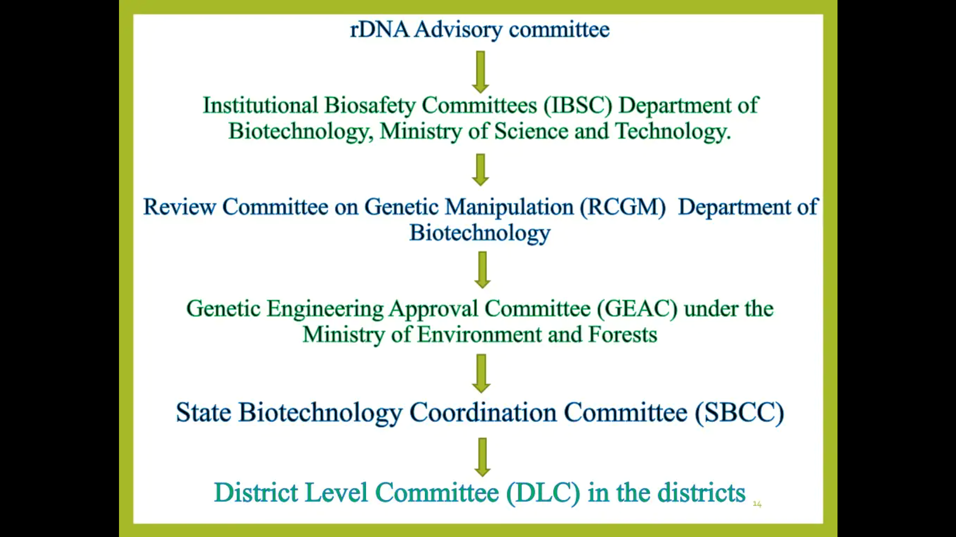

- Recombinant DNA Advisory Committee
The Advisory Committee functions under the Department of Biotechnology. The Committee scrutinizes national and international biotechnology developments. It shall make periodic recommendations, 'suitable and appropriate safety regulations', for GMO research and application. The Committee is to develop the long-term policy for research and development and educate researchers and technicians on the hazards and the methods to avoid those hazards (1990
Guidelines).

- Review Committee on Genetic Manipulation (RCGM)
The RCGM4 is constituted by the Department of Biotechnology to monitor safety related aspects in the ongoing research projects and activities involving genetically engineered organisms or micro-organisms. The Committee also brings out manuals on guidelines with respect to activities involving GMOs in research, use and applications. Every ongoing project involving 'high-risk category and control1ed field experiments' requires review by the RCGM for ensuring strict adherence to adequate precaution and containment. RCGM may appoint subcommittees.
The RCGM can lay down procedures restricting or prohibiting the production, sale, importation and use of GMOs. Use of GMOs or micro-organisms shall be carried out only in laboratories or inside laboratory areas notified by Environment Ministry. Educational experiments may be performed outside the notified laboratories and areas, provided they are overseen by the Institutional Biosafety Committees.

3. Genetic Engineering Approval Committee (GEAC) Apex Body

The GEAC functions under the Ministry of Environment and Forests and is responsible for approval of activities involving large-scale use of GMOs in research, industrial production and application. The GEAC issues clearance only from the environmental angle. The Committee authorises release of GMOs and products into the environment, including field trials. That means large-scale experiments beyond RCGM's jurisdiction have to be authorized by the GEAC only. The import, export, manufacture, processing or sale of any hazardous GMOs is approved by the GEAC. Normally, deliberate release of GMOs for experimental purposes into the environment or nature is not allowed. However in exceptional cases the GEAC may permit such release. GEAC authorisation is mandatory for the production, sale, import and use of foodstuff, ingredients in foodstuff and additives including processing and containing or consisting of GMOs. The GEAC
shall give directions to the occupier on discharge (-also the prohibition of discharge and the necessary measures) of GMOs or micro-organisms. GEAC approvals shall be for a maximum period of four years at the first instance; which are to be renewed every two years. The GEAC may fix the fee for meeting the expenses (in whole or part) incurred for approvals, examinations, supervisions and control. The GEAC approvals can be revoked on the basis of any new information on the harmful effects of GMOs, any damage to the environment, nature or health, not visualised at the time of approval and any instance of non-compliance with the prescribed conditions. Monitoring of the implementation of the terms and conditions of the approvals is done by the GEAC. The Committee can authorize the State Biotechnology Coordination Committee or State Po1lution Control Board or District Level Committee or any other person to do the necessary supervision. The Committee can take (or authorise any person to take) punitive actions for the violations of the Environment.

- Institutional Bio-safety Committee (IBSC)

The IBSC is the nodal point for interaction within the institution for implementation of the guidelines. Every research project using GMOs has to have an identified investigator who is required to get the research project approved from safety angle and inform the IBSC about the status and results of the experiments being conducted. An IBSC is to be constituted by an occupier or any person conducting research activities and handling GMOs. The Committee shall consist of the head of the institution, a medical expert, a scientist well versed in DNA work and a candidate of the DBT. The occupier or research institution shall prepare an updated on-site emergency plan (with the help of the IBSC) according to the manual or guidelines of the RCGM. The copies of the plans shall be served to the State, District Level Committees and the GEAC. A designated Principal Investigator (P.I.) in every research organization should acquaint the IBSC about the nature of experiments being carried out. The Investigator should obtain permission from the IBSC or from the RCGM (through the IBSC), if the risk falls in a higher category.

The functions of IBSC include to:
1 Reviewing and giving clearance to project proposals falling under restricted category as per DBT guidelines.
2 Recommending Category III risk or above experiments to RCGM for approval
3 Tailoring biosafety programme to the level or risk assessment.
4 Training of personnel on biosafety
5 Adopting emergency plans

The role of IBSCs assumes major importance since it is the only Statutory Committee, which operates from the premises of institution and hence is in a position to conduct onsite evaluation, assessment and monitoring of adherence to the biosafety guidelines. The decisions taken by the next higher committee i.e. Review Committee on Genetic Manipulation (RCGM), which operates from DBT are based on the applications submitted by the investigators with the approval of IBSC on the status of the project and its conformity with the regulatory guidelines.

5. State Biotechnology Co-ordination Committee (SBCC)

The SBCCs can 'inspect, investigate and take punitive actions' against statutory violations through the nodal department and the State Pollution Control Board or the Directorate of Health or Medical Services. The Committee shall undertake periodic; reviews of the safety and control measures in industries and institutes.

6. District Level Committee (DLC)

The DLCs at the district levels are to monitor the safety regulations in insta1Iations. The DLC or its representatives shall make on-site visits and find out hazards and risks associated, with a view to meeting any emergency. They shall prepare off-site emergency plans and shall regularly submit reports to the SBCC or the GEAC.

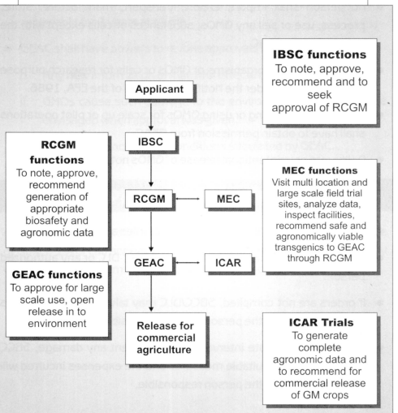

Convention on Biological Diversity (CBD)

The Convention on Biological Diversity (Biodiversity Convention, CBD) was adopted at the United Nations Conference on Environment and Development (UNCED) in Rio de Janeiro in 1992. The Convention now has a total of 193 Parties. It was ratified by Switzerland in 1994.
The signatory states of the CBD undertake to conserve biodiversity in their own territories, support appropriate measures for the conservation and sustainable use of biodiversity in developing countries, and regulate equitably the access to genetic resources and their utilisation. In April 2002, the Parties to the CBD undertook to reduce the rate of biodiversity loss significantly by 2010. Unfortunately, the agreed target of significantly reducing the current rate of biodiversity loss by 2010 was not attained. The global Strategic Plan for Biodiversity 2011-2020 and new biodiversity goals, the 20 Aichi Biodiversity Targets, for the decade to 2020, known as the Aichi Biodiversity Targets, were defined at the Conference of the Parties in Nagoya in October 2010. The measures to be attained under the strategic plan and goals include the elimination of counterproductive incentives, the improved interconnection of protected areas and the sustainable use of areas with an economic function. To ensure the long-term conservation of biodiversity, on behalf of the Federal Council, the Department of Environment, Transport, Energy and Communications (DETEC) developed a national biodiversity strategy. It was passed by the Federal Council on 25 April 2012. The associated action plan should be completed by the end of 2017. It will define concrete measures for the ten strategic goals so that the conservation of biodiversity in Switzerland can be guaranteed in the long term.

The Cartagena protocol on biosafety

The Cartagena Protocol on Bio-safety is the first international regulatory framework for bio-safety, negotiated under the aegis of the Convention on Biological Diversity (CBD). Named after the Columbian city where the final round of talks were launched, the Cartagena Protocol on Biosafety sets out a comprehensive regulatory system for ensuring the safe transfer, handling and use of Living Modified Organisms (LMOs) with a focus on transboundary movement. The Protocol deals primarily with LMOs that are to be intentionally introduced into the environment (such as seeds, trees or fish) and with genetically modified farm commodities (such as corn and grain used for food, animal feed or processing). It does not cover pharmaceuticals for humans addressed by other international agreements and organizations or products derived from LMOs, such as cooking oil from genetically modified corn.

The Convention on Biological Diversity was finalized in Nairobi in May 1992 and opened for signature at the United Nations Conference on Environment and Development (UNCED) in Rio de Janeiro on 5 June1992. It entered into force on 29 December 1993. Today, the Convention is the main international instrument for addressing biodiversity issues. It provides a comprehensive and holistic approach to the conservation of biological diversity, the sustainable use of natural resources and the fair and equitable sharing of benefits deriving from the use of genetic resources. Biosafety is one of the issues addressed by the Convention. This concept refers to the need to protect human health and the environment from the promotion of human well-being, particularly in meeting critical needs for food, agriculture and health care. The Convention clearly recognizes these twin aspects of modern biotechnology. On the one hand, it provides for the access to and transfer of technologies, including biotechnology, that are relevant to the
conservation and sustainable use of biological diversity. On the other hand, it ensure the development of appropriate procedures to enhance the safety of biotechnology in the context of the Convention’s overall goal of reducing all potential threats to biological diversity, taking also into account the risks to human health. At its second meeting, held in November 1995, the Conference of the Parties to the Convention established an Open-ended Ad Hoc Working Group on Biosafety to develop a draft protocol on biosafety, focusing specifically on transboundary movement of any living modified organism resulting from modern biotechnology that may have adverse effect on the conservation and sustainable use of biological diversity. After several years of negotiations, the Protocol, known as the Cartagena Protocol on Biosafety to the Convention on Biological Diversity, was finalized and adopted in Montreal on 29 January 2000 at an extraordinary meeting of the Conference of the Parties.

The Protocol was adopted on 29th January 2000 and entered into force from September 11, 2003. As on date, 135 countries have ratified the Protocol. The governing body of the Protocol is the Conference of Parties to the Convention serving as the meeting of the Parties to the Protocol i.e. COP/MOP. The main function of this body is to review the implementation of the Protocol and make decisions necessary to promote its effective operation.

India ratified the Protocol on January 23, 2003 and the Ministry of Environment & Forests (MoEF) is the nodal ministry for implementation of Cartagena Protocol. MoEF has taken several initiatives to meet its obligations to the Protocol including capacity building of various stake holders for its effective implementation in the country. MoEF is implementing a GEF- World Bank funded Capacity Building Project on Biosafety with an objective to strengthen of regulatory framework, particularly on transboundary movement of living modified organisms (LMOs)/ genetically modified organisms (GMOs), risk assessment and management, training and human resource development and information sharing.
The Cartagena Protocol on Biosafety is an extremely important development in the international regulation of genetically modified organisms (GMOs) and genetic engineering. It is the first international law to specifically regulate GMOs and genetic engineering.

Major elements of the protocol:

The various elements of the protocol are:
1 Advance informed Agreement procedure
2 Simplified system for agricultural commodities
3 Risk assessments
4 Risk management and emergency procedures
5 Export documentation
6 Bio-safety clearing House
7 Capacity-building and finance
8 Public awareness and participation
9 Issue of non-parties.

Main features of Cartagena Protocol
• It creates an advanced informed agreement (AIA) procedure
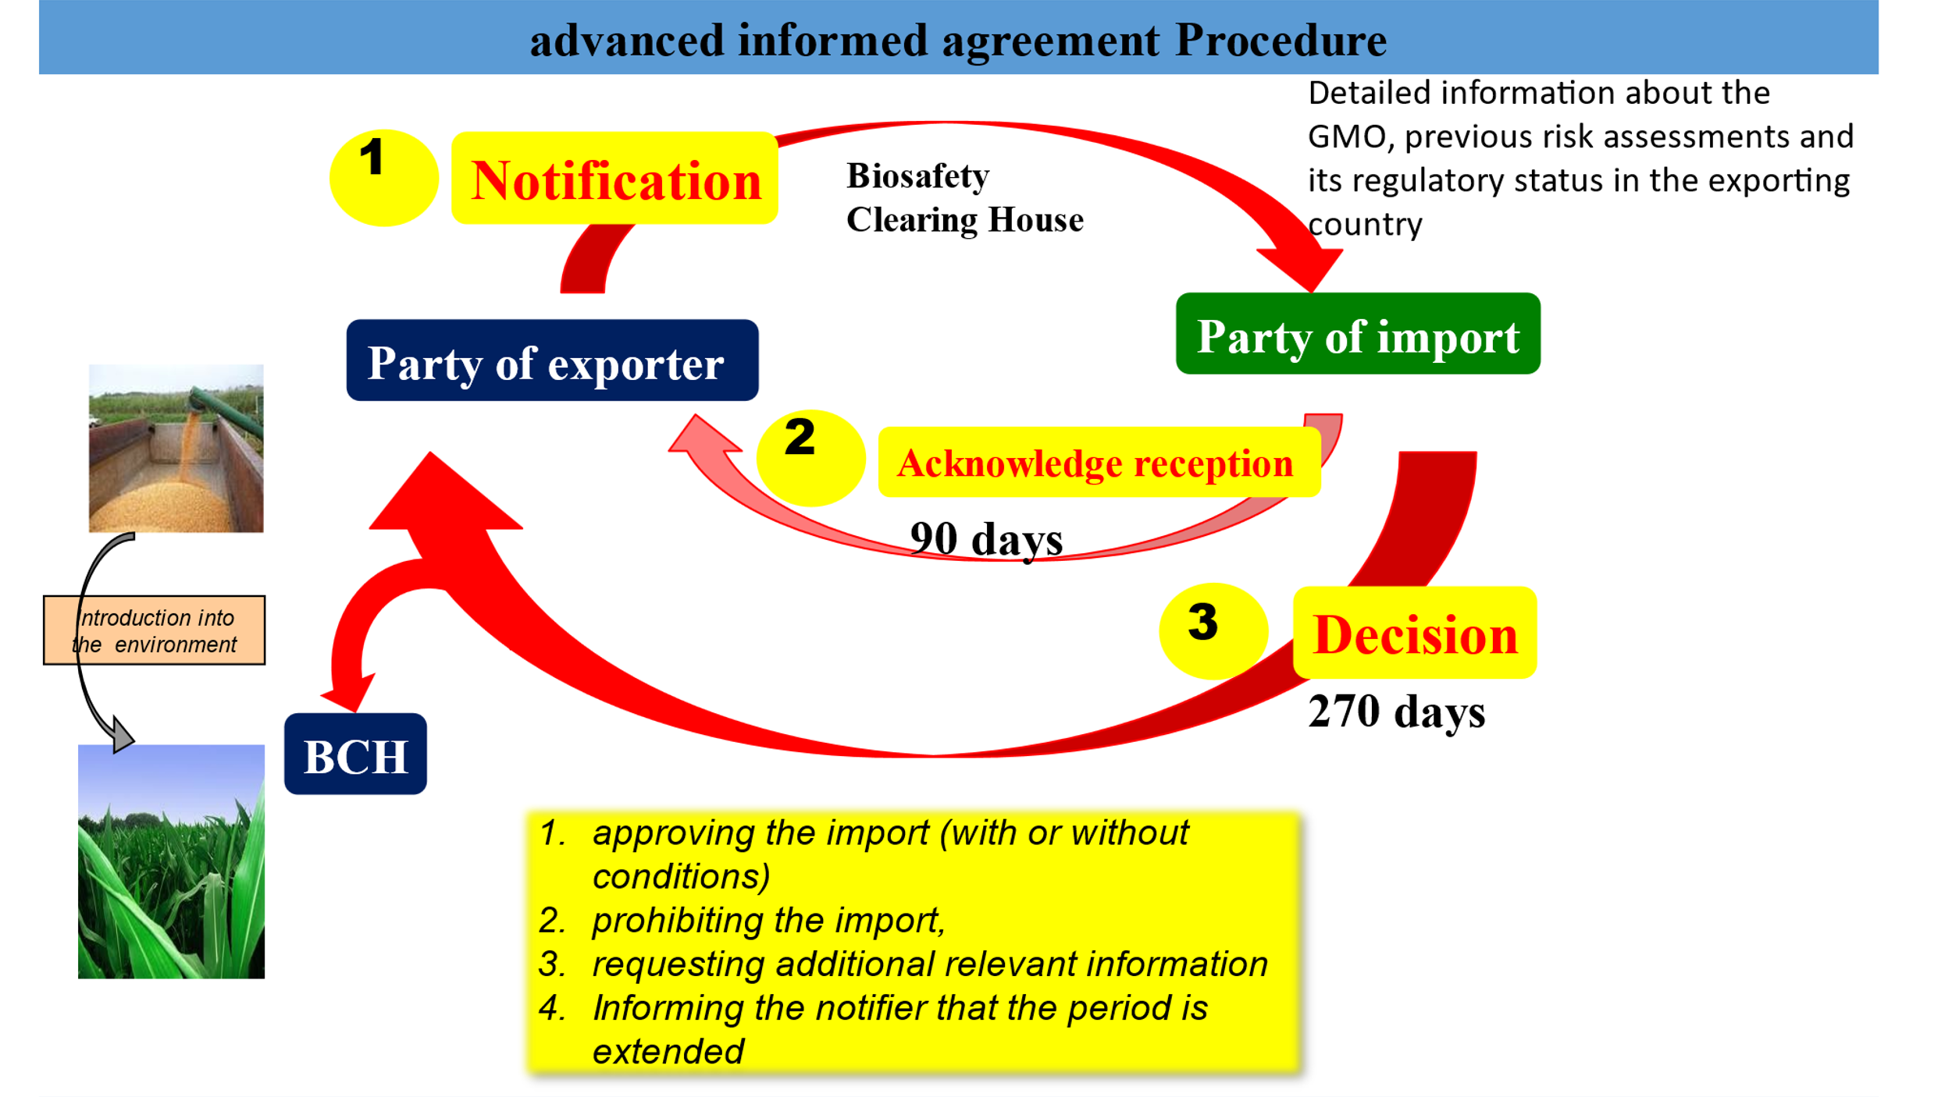

Advanced Informed Agreement (AIA) procedure
- The exporter must provide a notification to the importing country containing detailed information about the GMO, previous risk assessments of the GMO and its regulatory status in the exporting country through BCH .
- The BCH is an information-sharing mechanism website
- Biosafety Clearing-House” to help countries exchange scientific, technical, environmental and legal information about GMOs.
- The importing country must acknowledge receiving the information within 90 days
- In either case, the importing country must decide whether to allow the import, with or without conditions or deny it within 270 days.

